

Entry Pack
Make your entry stand out from the rest.
It pays to present your scheme well.

Closing Date for Entries:

Saturday 30th June 2012

ALCI Landscape Awards 2012

The ALCI Landscape Awards are held to celebrate our industry’s commitment to maintaining and improving standards in the Landscape Sector.
They pay tribute to ALCI members across Ireland, North and South, who demonstrate exceptionally high standards of professionalism and skill in the execution of a wide variety of landscape projects.

Entry Guidelines

- The Landscape Awards are made annually by the Association of Landscape Contractors of Ireland to encourage and foster higher standards of construction and design in landscaping.

- The Entry Application to be submitted by Contractor who is a Full Member of ALCI.

- The 2012 Landscape Awards are for contracts that have a Practical Completion of construction work during the period: 1st January 2009 – 30th June 2012

- Entries in each category will be assessed upon their quality and standards of professional workmanship.

- Applicants must enter the Awards by means of the entry pack and Entry Fee. The entry fee is €25 + VAT(€30.75) for the first entry and €35 + VAT(€43.05) for each subsequent entry. The closing date for submissions is Saturday 30th June 2012. The Entry Form must be completed in full and must include all information and entry material requested. All materials are submitted at Entrant’s own risk.

- An Entry will not be accepted unless the Entry Fee is enclosed.

- Contracts which have won Category Awards in any year cannot be entered again, except under the Maintenance Category. However, any Entry that has been awarded an AWARD OF MERIT may be entered again in any Category.

- If more than one Contractor is involved in a particular Scheme (Landscape Scheme) this fact should be clearly stated on the Entry Form and particular areas which are being entered should be clearly defined.

- The Client must be agreeable to allow entry into the Landscape Awards Scheme. If necessary, a letter of agreement must be obtained and submitted with further permission allowing inspection of properties involved: this information is to be submitted with the Entry.

- Judging of the entries is expected to take place during August. Entrants will be advised in advance if their site is to be visited. Contactors must not be present when judging is taking place.

- The Independent Adjudicators will be appointed by each Region of the Association. The Adjudicators’ decisions are final and no correspondence will be entered into.

- Entries will be visited by an Adjudicator at their discretion.

- Awards and Awards of Merits will be made in each category entirely at the discretion of the judges. Awards will be made to the Landscape Contractor who completed the work, to the designer (who may also be the Contractor) and to the client whose property was landscaped.

- The Bog Oak Trophy will be presented to the Best Overall Entry, and will be kept in confidence and announced at the Awards Night on Friday 12th October in the Slieve Donard hotel, Newcastle, Co Down.

Entry Form 
To be completed by entrant
(Block Capitals Please. Ensure that all information on your entry form is correct.)

Category of Entry: (Listed on pg. 5 of this form)
________________________

Contact Details of ALCI Contractor: Contact Details of Client:

Name: Name:
________________________ ______________________

Company Name & Address: Address:
_______________________________ _____________________________
_______________________________ _____________________________
_______________________________ _____________________________
_______________________________ _____________________________

_______________________________ _____________________________

Tel: Tel:
_______________________________ _____________________________

Email: Email:
_______________________________ _____________________________

Project Title & Full Address: Name and Address of Architect or Designer: (where applicable)

Title: Name:
_______________________________ _____________________________
_______________________________ Address:
Address: _____________________________
_______________________________ _____________________________
_______________________________ _____________________________
_______________________________ _____________________________
_______________________________ _____________________________
_______________________________ _____________________________

Please tick box if the client has requested the address of the project to remain anonymous □
Please tick box if the client has requested their name be listed as Private Client □

CLOSING DATE FOR RECEIPT OF ENTRY MATERIAL
Saturday 30th June 2012

Financial:
(Cost inclusive of VAT)

Cost of Construction to practical completion

€ __________________________________

Construction Categories only: Project Description

Please provide a clear, informative description of the scheme, explaining the scope of the contract, the nature of the work, the client’s requirements and any specific briefing. It should include details of any unusual features and challenges that were overcome during the course of the work. The contractor must also clearly explain in the project description any areas or aspects of work for which others have been responsible. The description should be typed on a separate A4 sheet.

Maintenance only categories: Specifications

Please give details below of how long you have been carrying out the maintenance and specification of work – a full list of what is included in the maintenance contract is required (NB. You must have been responsible for maintenance for a minimum of 12 months at date of submitting entry).
________________________________________________________________________________________________________________________________________________________________________________________________________________________________________________________________________________________________________________________________________________________________________________________________________________________________________________________________________________________________________________________

Photographs:

- All applicants are required to submit at least two representative high resolution photographs; in both hard copy and electronically on a disc. Please note these photographs will be used for PR, display purposes on the awards night and for diary publications. It is in your interest to provide good quality photographs.
- Additional supporting photographs may also be submitted i.e. to emphasise particular areas or features or to illustrate the effectiveness of the scheme through before and after shots.

Plans

A clean copy of the overall project plan should be provided with each entry. Supporting plans demonstrating particular aspects of the project can also be included.

Location Map

This should be comprehensive (preferably an online map service e.g. Google Maps) and marked to show the location and directions very clearly.

Access

It should be clearly stated on the entry form if a site has restricted access and details of how the adjudicator can gain access to site must be included.

Authority

I/We confirm that the client/designer/architect has given permission for this scheme to be entered and for the site to be visited for judging purposes.

I/We have read conditions and enclose the materials requested.

I/We affirm that the enclosed material and photographs are free of copyright or other restrictions in connection with their product.

I/We accept full responsibility for the completeness and accuracy of the details I/We have provided and understand that the information I/We have provided will be used in presentation material, certificates, press releases and PR.

I/We understand that ALCI reserves the right to return any material submitted as being unsuitable and to request replacement by closing date.

Signed: ____________________________________

Date: ____________________________________

Categories

- Private Gardens Under €5,000
- Private Gardens between €5,000 - €10,000
- Private Gardens Between €10,000 - €30,000
- Private Gardens Over €30,000
- Private Gardens Maintenance
- Residential Development Under
- Commercial Development
- Public Authority
- Residential, Commercial & Public Authority Maintenance
- Sportsgrounds Construction
- Sportsgrounds Maintenance

Marking Scheme & Judging Criteria

Application Form Information 10 Marks
The quality of information provided on the work done, specification, location, travel directions and contact details

Overall Impression 10 Marks
The general impact that the scheme makes in the initial stages of the inspection

Soft Landscape Material 30 Marks
The standard of plant material used in the scheme including lawn areas where they exist

Hard Landscape Material 30 Marks
The standard of materials used in the construction of paved areas, walls and other features including kerbs, steps, seating etc.

Scale of Endeavour 10 Marks
The extent of challenges faced by the contractor in completing the work. Extra works entailed in features such as pools, fountains, sculpture etc.

Merit Points 10 Marks
The overall quality of the scheme in regard to the standard appropriate for an award

Note: Where hard landscape elements in a scheme are not the responsibility of the contractor, the maximum score out of 70 marks will be converted to a percentage.

Judge’s Comments

You will note that we have included 10% for the quality of information received from the contractor. That was done to give credit to those who took the time and interest in providing the judges with basic information about what they did and where the site is located. The motivation is to encourage the contractors to provide more information, especially those who have submitted weak and incomplete applications in the past.
The next 10% is for overall impression. In a way, this deals with design and how the scheme either makes an impression or doesn’t make an impression.
The meat in the judging is the soft and hard landscape elements (30% each) and we devised a scheme to cater for situations where the hard landscape work was not the responsibility of the ALCI member. Previous criteria had allocated marks to lawns, borders etc. We found those systems unworkable because lawns for example varied in size from one scheme to another and didn’t exist at all in some.
Another criterion we devised was the scale of endeavour (10%) which was aimed at considering the challenge that the contractor had encountered. It gave us flexibility to recognise such difficulties where they existed.
Finally, we included a merit criterion which essentially related to whether we felt that the achievement was award status.

2012 Judges
Dr Christy Boylan, Landscape Consultant, Vice-President IFPRA
Gary Graham, Bloom Manager, DME Amenity Horticulture Bord Bia

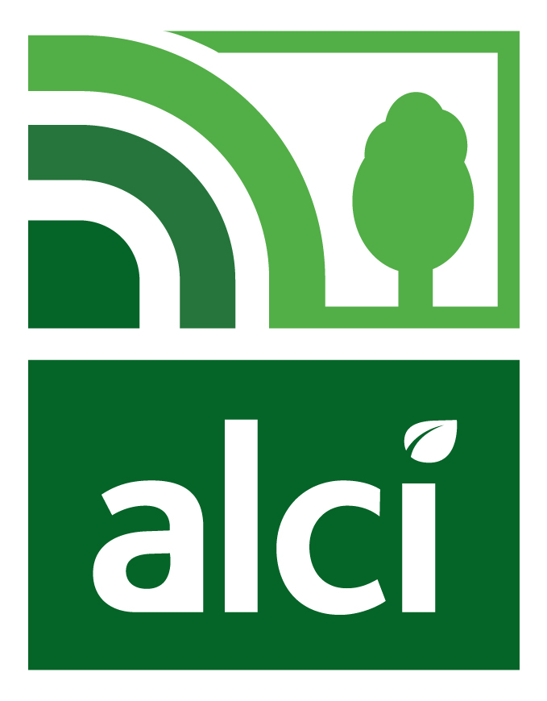
Check List
Entry Material to be submitted
All Entrants

Completed official entry form & fee | ◻
Project Description/specification | ◻
Copy of Project Plan | ◻
Two representative photographs – hard copy | ◻
Two High Resolution Digital photographs on disc | ◻
Location Map with clear directions | ◻

Please return completed Entry Form and €30.75 Fee for the first entry and €43.05 Fee for each subsequent entry to your ALCI Regional Office by the closing date of Saturday 30th June 2012.

Southern Region Office: Ross Carew
ALCI
2 Martello Terrace
Sandycove
Co Dublin

